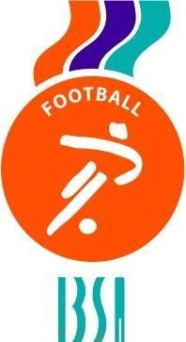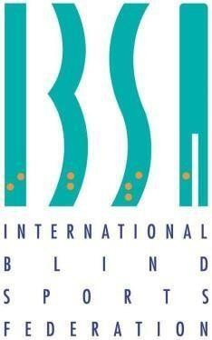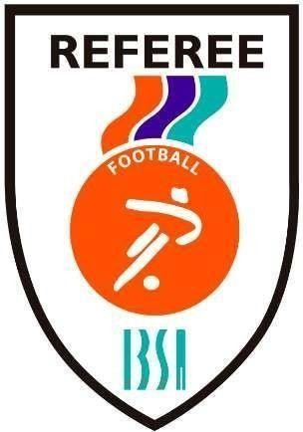

21st April, 2023

Distinguished IBSA Member Federations:

After the receipt of all match reports from official Games, the sanctions could be officially published at IBSA Webpage valid from 21st April 2023:
Mr. Crisanto Antonio Lopez, player of Cape Verde, cannot participate in next official IBSA match of Cape Verde.
Mr. Bachana Margvelashvili, player of Georgia, cannot participate in next official IBSA match of Georgia.

Mr. Uzum Ibrahim, player of Turkey, cannot participate in any official IBSA match of Turkey until 31st December 2024.

Mr. Jorge Andrés Farias Caceres, player from Chile, cannot participate in the next 2 official IBSA matches of Chile.

IBSA Football Subcommittee

