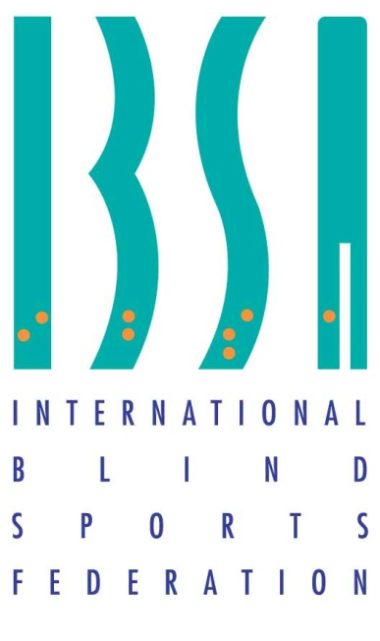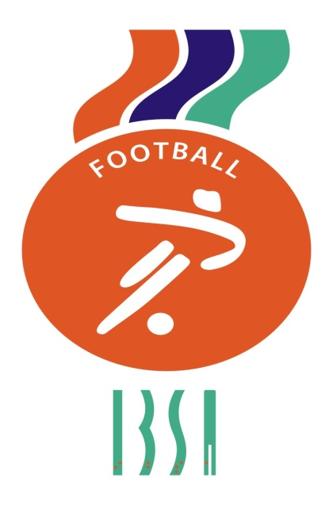

INTERNATIONAL BLIND
SPORTS FEDERATION
PARTIALLY SIGHTED FUTSAL
LAWS OF THE GAME
2024

IBSA (International Blind Sports Federation) Football Subcommittee

PRESIDENT

Elias Mastoras
football.chair@ibsasport.org
MEMBERS

Fabio Luiz Ribeiro de Vaconcelos
Maurizio Di Silvestro
Dorien Cornelis
Orhan Tanrikulu

REFEREEING AND LAWS OF THE GAME COORDINATOR

Partially Sighted Futsal
Referee Coordinator
Toni Lehtinen
tonil@hotmail.com

Should there be any discrepancy in the interpretation of the IBSA Partially Sighted Futsal Laws of the Game the English version shall prevail.

January 2024
IBSA PARTIALLY SIGHTED FUTSAL – LAWS OF THE GAME

The Laws of the Game for the IBSA Partially Sighted Futsal are governed by the current FIFA Futsal Laws of the Game with the following IBSA adaptations:
Modifications to the previous rules of the game are marked with the following symbol (asterisk): *

1. All efforts should be made to avoid reflections caused by sunlight or artificial light on the field of play as these reflections may adversely affect or limit the match and the players’ movement.

2. Light must be equally intense on all parts of the field of play and during the entire match. Variations in light intensity are prohibited in all circumstances.

The Ball

3. The ball used in this category may be of a colour that clearly contrasts from the pitch and the lines. The ball must conform to Law 2 FIFA Futsal Laws of the Game.

The Number of Players and classification

4. A team could have up to 12 players in the match sheet. These 12 players must be divided into 10 players + 2 goalkeepers. In the tournament, a team can have up to 15 players. *

5. A team shall NEVER have more than two B3 players on the pitch. *

6. Goalkeeper’s classification is not taken into consideration when determining the number of B2 and B3 players.

7. Players classed as B3 shall wear an armband on their right arm. This armband should be of a different colour from their jerseys, this armband must also be a different colour to BOTH team captains' armbands if worn, which MUST be worn on the LEFT ARM.

8. It is recommended that each team bring at least THREE B2 players to each competition. But they MUST have a minimum of two B2 players at the beginning of the competition.

9. Should a B3 player enter the match in breach of the law regarding the maximum number of players per sight category, the infringement shall be sanctioned in the following manner:
• Play shall be stopped. Unless advantage can be applied to the opposing team.
• The player committing the infringement shall be cautioned.
• The player committing the infringement shall be ordered to leave the field of play.
• Play is restarted with an indirect free kick for the opposing team from the position of the ball when play was stopped.

Goalkeeper´s play

10. If a goalkeeper deliberately leaves their penalty area AND interferes with play or interferes with an opponent, they shall be shown a red card if they deny an obvious goal-scoring opportunity.
In other cases, a yellow card for unsporting behaviour MAY be the minimum sanction. The referee shall award a direct free kick to the opposing team, to be taken from the place where the goalkeeper touched or played the ball or interfered with an opponent. This is an accumulated foul.
The exception to this rule is rule number FOURTEEN below.

11. If a goalkeeper kicks the ball deliberately, when it is in play or from the free kick, beyond the halfway line without touching the goalkeeper’s half of the pitch or another player in the goalkeeper’s half, an indirect free kick is awarded to the opposing team anywhere on the halfway line if advantage cannot be applied to the opposing team.
A goalkeeper at any time is permitted to take a free kick from inside their own penalty area.
A fully-sighted goalkeeper cannot score a goal in any circumstance.
This includes Penalties (penalty shoot-out).

12. If a goalkeeper throws the ball deliberately, when it is in play or at a goal clearance, beyond the halfway line without it touching the goalkeeper’s half of the pitch or touching another player in the goalkeeper's half, an indirect free kick shall be awarded to the opposing team anywhere on the halfway line if advantage cannot be applied to the opposing team.

13. In case the injured player will be the goalkeeper, the further exception to
the requirement to leave the pitch is when the team has no fully sighted substitute goalkeeper. *

Power Play

14. FOR “Power play” situations. It is permitted to change a fully sighted goalkeeper WITH A B2 or B3 PLAYER in the following circumstances ONLY.

(i) ONLY the team who are LOSING by one goal or more may make this change.
(ii) The change MUST be the goalkeeper off and a B2 or B3 player ON as the goalkeeper.
(iii) Substitutions MUST be made as per the Laws of Futsal at the substitution zone by exchanging the bibs. It is not necessary to do this at a stoppage in the game.
(iv) Players entering as the GK in Power play situations MUST be dressed according to Laws 3 and 4 of the FIFA Futsal Laws.
BIBS are not permitted in ANY circumstance.
B3 players must wear appropriate armbands on the GK jersey.
(v) During this change the goalkeeper can play out on the pitch as an extra player and the Laws of Futsal apply them. They may score a goal in this case.
(vi) If the team playing Power play equalize, they automatically return to the original rules regarding the goalkeeper. Whether they substitute the B2 or B3 goalkeeper or NOT.

Note:
Power Play situations allow either a B2 or B3 player to play as the goalkeeper. In both cases, there are Five Visually impaired players playing against Four plus a fully sighted goalkeeper. Laws 10,11,12 and 13 above do NOT apply during the Power Play situation because the goalkeeper is visually impaired.

